Berkshire Travel Agency
PRESENTS
A 14-DAY BEST OF NORWAY
Aboard the

ROTTERDAM
July 9 – 24, 2022
HOSTED BY FATHERS:

JOHN YONKOVIG, DON HENRY, TOM RYAN AND TIM TAUGHER

CRUISE ITINERARY
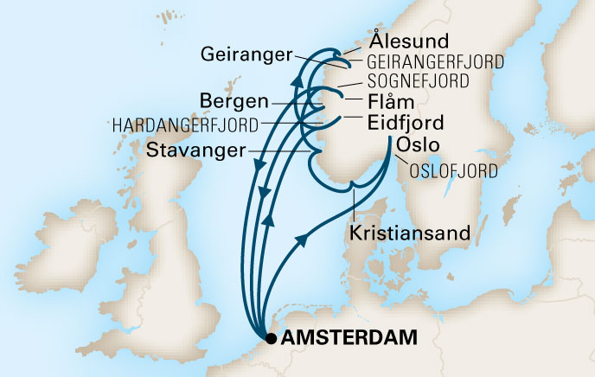
Day | Port | Arrive | Depart
Sat | Overnight flight to Amsterdam, The Netherlands
Sun | Depart Amsterdam1 |  | 5:00pm
Mon | Sea Day
Tue | Scenic cruising Oslofjord2
Tue | Oslo. Norway | 8:00am | 4:00pm
Wed | Kristiansand, Norway | 8:00am | 5:00pm
Thu | Stavanger, Norway | 8:00am | 3:00pm
Fri | Scenic cruising Sognefjord2
Fri | Flam, Norway 3,4 | 7:00am | 7:00pm
Sat | Sea Day
Sun | Amsterdam, Netherlands1
Mon | Sea Day
Tue | Eidfjord, Norway | 7:00am | 3:00pm
Tue | Scenic cruising Hardangerfjord2
Wed | Alesund, Norway | 8:00am | 5:00pm
Thu | Geiranger, Norway 3,4 | 7:00am | 5:00pm
Thu | Cruising Geirangerfjord2
Fri | Bergen, Norway | 8:00am | 5:00pm
Sat | Sea Day
Sun | Debark Amsterdam1 | 7:00am

1-times are subject to Canal Transit/2-cruising only/3-tender required/4-wheelchair access limited

BOOK BY 2/28/21 FOR FREE DRINKS, FREE GRATUITIES, FREE SPECIALTY DINING, REDUCED (refundable) DEPOSIT AND MORE!!

Limited on time? Inquire about our 7-day sailing July 10-17, 2022.

VALID U.S. PASSPORT REQUIRED FOR TRAVEL
(passport should be valid for at least 6 months from return date)

BERKSHIRE TRAVEL GROUP RATES
(Per person/double Occupancy)

CATEGORY STATEROOM DESCRIPTION BERKSHIRE RATE
J INSIDE STATEROOM $2,855.00
E OUTSIDE STATEROOM $3,454.00
VD VERANDAH STATEROOM $3,805.00
Other categories and single, triple and quad rate available upon request.
AIRFARES NOT INCLUDED. AIR PRICES WILL BE AVAILABLE AUGUST 2021. BERKSHIRE TRAVEL RATE INCLUDES:
- Cruise accommodations as desired
- Port taxes and government fees
- Meals and entertainment on board ship
- Cocktail party for group

NOT INCLUDED:
Any items of a personal nature purchased either on board ship, at any of the ports-of-call
and during land tour. Gratuities on board ship. Airfare and transfers.

CANCELLATION PROTECTION PLAN:
Cancellation insurance is available and highly recommended. Please ask Berkshire
Travel about coverage. Insurance may be purchased with either deposit or added
at final payment. Rate is based on category selected.

DEPOSIT AND PAYMENT:
A deposit of $600.00 per person is required to secure a stateroom. Deposits are refundable up to 91 days prior to departure. You will be invoiced for final payment due April 6, 2022. Please make all checks payable to Berkshire Travel. We also accept and PREFER Visa, Master card, Discover and American Express.

FOR ADDITIONAL INFORMATION CONTACT: Kathy Coll
at Berkshire Travel Group Dept.
(610) 372-4652/800 223-3884
Email: btagroups@gmail.com

RESERVATIONS MADE BY BERKSHIRE TRAVEL AGENCY
Located at:
2 Woodland Rd, Wyomissing PA 19610
610-372-4652 / 800-223-3884

